Sequence Diagram: Event Filtering
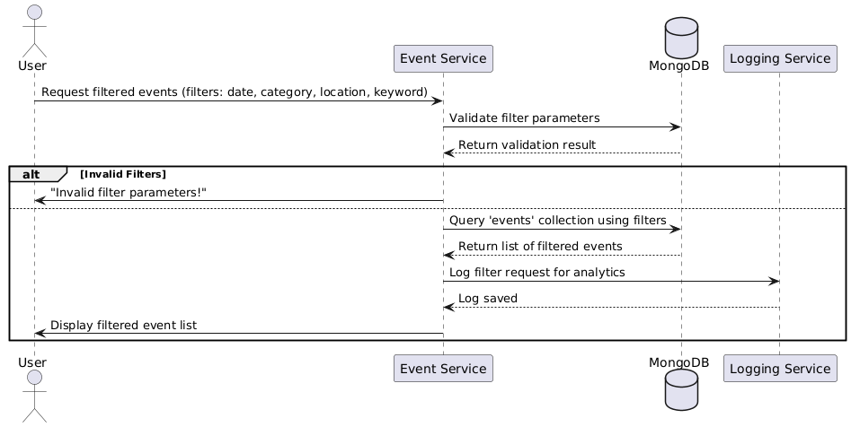

Database
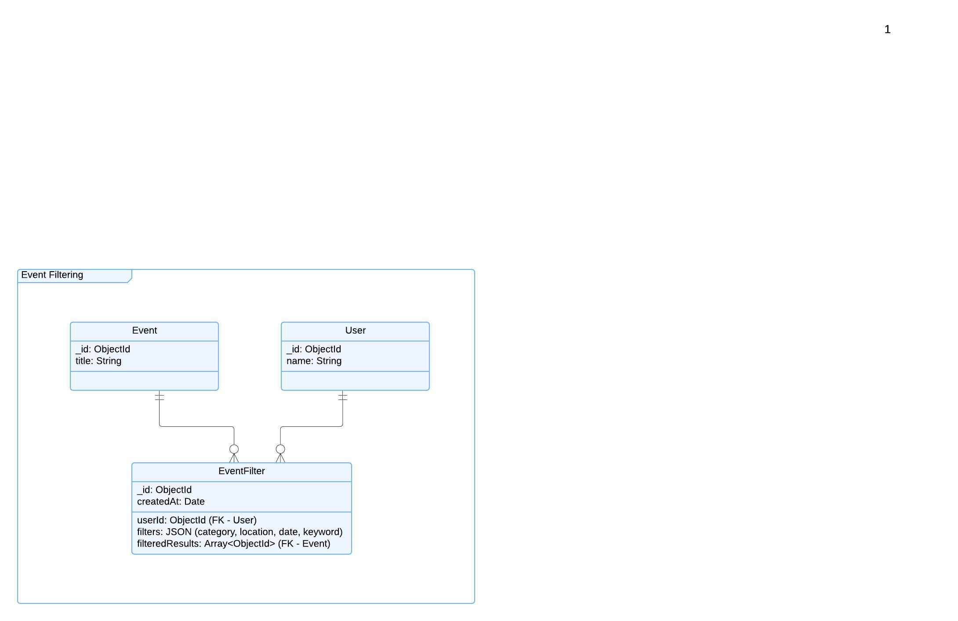

Functional Requirements (FRs)
- FR1: Users shall be able to filter events based on date, category, location, and keywords.
- FR2: The system shall validate filter input before querying the database.
- FR3: The system shall return a list of matching events.
- FR4: The system shall allow users to save their preferred filters for quick access.
Non-Functional Requirements (NFRs)
- NFR1: Filtering operations should return results in less than 1 second.
- NFR2: The system should support advanced search indexing for fast query execution.
- NFR3: The filtering system should handle at least 500,000 queries per minute during peak load.

